`

**LAB 03**

**D**

**ATA**

**T**

**YPES**

**& A**

**SSEMBLY**

**I**

**NSTRUCTIONS**

Syed Muhammad Faheem

20K-1054

3E

STUDENT NAME

ROLL NO

SEC

______________________________________

SIGNATURE & DATE

**MARKS AWARDED: ______________**

___________________________________________________________________

**NATIONAL UNIVERSITY OF COMPUTER AND EMERGING SCIENCES**

**(**

**NUCES), KARACHI**

Prepared by:

Amin Sadiq

Version:

Date:

1.0

17

th

Sep 2021



Lab Session 03~~:~~ DATA TYPE & ASSEMBLY INSTRUCTIONS

**Objectives:**

* Defining Data
* Data Definition Statement
* Data Initializations
* Multiple Initializations
* String Initialization
* Assembly language Instructions: MOV , ADD , SUB
* Sample Program
* Exercise

**Data Types:**

MASM defines **intrinsic data types**, each of which describes a set of values that can be assigned to variables and expressions of the given type.



|  |  |
| --- | --- |
| **BYTE** | 8-bit unsigned integer |
| **SBYTE** | 8-bit signed integer. S stands for signed |
| **WORD** | 16-bit unsigned integer |
| **SWORD** | 16-bit signed integer |
| **DWORD** | 32-bit unsigned. D stands for double |
| **SDWORD** | 32-bit signed integer |
| **QWORD** | 64-bit integer. Q stands for quad |
| **TBYTE** | 80-bit integer. T stands for ten |

**Data definition statement:**

A data definition statement sets aside storage in memory for a variable, with an optional name.

Data definition statements create variables based on intrinsic data types.

A data definition has the following syntax:

**[name] directive initializer [,initializer]...**

**Initializer:** At least one initializer is required in a data definition, even if it is zero. Additional initializers, if any, are separated by commas. For integer data types, initializer is an integer constant or expression matching the size of the variable’s type, such as BYTE or WORD. If you prefer to leave the variable uninitialized (assigned a random value), the ? symbol can be used as the initializer.

***Examples***:

value1 **BYTE** 'A' ; character constant value2 **BYTE** 0 ; smallest unsigned byte value3 **BYTE** 255 ; largest unsigned byte value4 **SBYTE** −128 ; smallest signed byte value5 **SBYTE** +127 ; largest signed byte

greeting1 **BYTE** "Good afternoon”, 0 ; String constant with null terminated string greeting2 **BYTE** 'Good night' ; String constant greeting1 **BYTE** 'G','o','o','d' ; String constant

The hexadecimal codes 0Dh and 0Ah are alternately called CR/LF (carriage-return line-feed) or end-of-line characters.

list BYTE 10,20,30,40 ; Multiple initializers

Note: A question mark (?) initializer leaves the variable uninitialized, implying it will be assigned a value at runtime: value6 BYTE ?



**DUP Operator**

The DUP operator allocates storage for multiple data items, using a constant expression as a counter. It is particularly useful when allocating space for a string or array, and can be used with initialized or uninitialized data.

***Examples:***

v1 BYTE 20 DUP(0) ; 20 bytes, all equal to zero v2 BYTE 20 DUP(?) ; 20 bytes, uninitialized

v3 BYTE 4 DUP("STACK") ;20 bytes, "STACKSTACKSTACKSTACK"

**Operand Types:**

As x86 instruction formats:

[label:] mnemonic [operands][ ; comment ]

Because the number of operands may vary, we can further subdivide the formats to have zero, one, two, or three operands.

Here, we omit the label and comment fields for clarity:

**mnemonic**

**mnemonic [destination] mnemonic [destination],[source] mnemonic [destination],[source-1],[source-2]**

x86 assembly language uses different types of instruction operands. The following are the easiest to use:

* Immediate—uses a numeric literal expression
* Register—uses a named register in the CPU
* Memory—references a memory location

Following table lists a simple notation for operands. We will use it from this point on to describe the syntax of individual instructions.



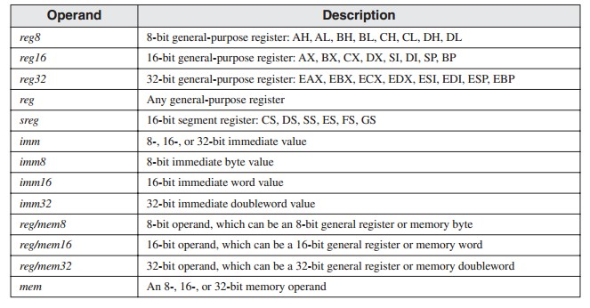

**MOV Instruction:**

It is used to move data from source operand to destination operand ● Both operands must be the same size.

* Both operands cannot be memory operands.
* CS, EIP, and IP cannot be destination operands.
* An immediate value cannot be moved to a segment register.

*Syntax*:

MOV destination, source

Here is a list of the general variants of MOV, excluding segment registers:

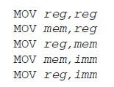

***Example:***

MOV bx, 2

MOV ax, cx



***Example:***

‘A’ has ASCII code 65D (01000001B, 41H)

The following MOV instructions stores it in register BX:

MOV bx, 65d

MOV bx, 41h

MOV bx, 01000001b

MOV bx, ‘A’

All of the above are equivalent.

***Examples:***

The following examples demonstrate compatibility between operands used with MOV instruction:

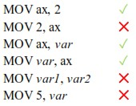

**ADD Instruction**

The ADD instruction adds a source operand to a destination operand of the same size. Source is

unchanged by the operation, and the sum is stored in the destination operand

***Syntax***:

ADD dest,source

**SUB Instruction**

The SUB instruction subtracts a source operand from a destination operand.

***Syntax***:

SUB dest,source

**Sample Program:**

TITLE Add and Subtract (AddSub.asm)

; This program adds and subtracts 32-bit integers.

INCLUDE Irvine32.inc

.code

main PROC



|  |  |
| --- | --- |
| mov eax,10000h | ; EAX = 10000h |
| add eax,40000h | ; EAX = 50000h |
| sub eax,20000h | ; EAX = 30000h |
| call DumpRegs | ; display registers |

exit

main ENDP END main

**Lab Exercise:**

1. Write an uninitialized data declaration for a16-bit signed integer val1. Initialize 8-bit signed integer val2 with -10.
2. Declare a 32-bit signed integer val3 and initialize it with the smallest possible negative decimal value. (Hint: Use SDWORD)
3. Declare an unsigned 16-bit integer variable named wArray that uses three

Initializers.

1. Declare a string variable containing the name of your favorite color. Initialize it as a null terminated string. Initialize five 16-bit unsigned integers varA, varB, varC, varD & varE with the following values: 12, 2, 13, 8, 14.
2. Convert the following high-level instruction into Assembly Language:

ebx = { (a+b) – (a-b) + c } +d a= 10h , b=15h, c=20h, d=30h

1. Convert the given values of a,b,c,d into binary and then use in 8-bit data definition and implement in the equation.



1. Write a program in assembly language that implements following expression: Eax = imm8 + data1 – data3 + imm8 + data2

Use these data definitions:

Imm8 = 20

Data1 word 8

Data2 word 15

Data3 word 20

**COAL Lab 3 Tasks**

**Task # 1:**

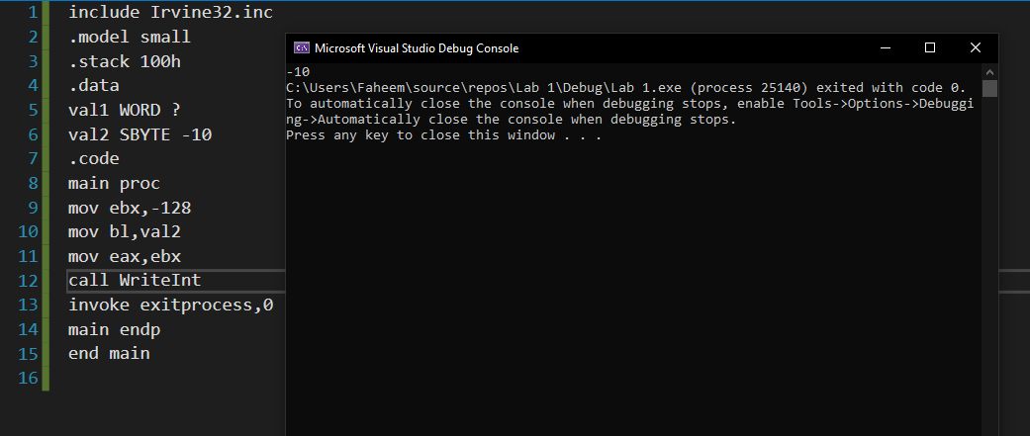

**Task # 2:** 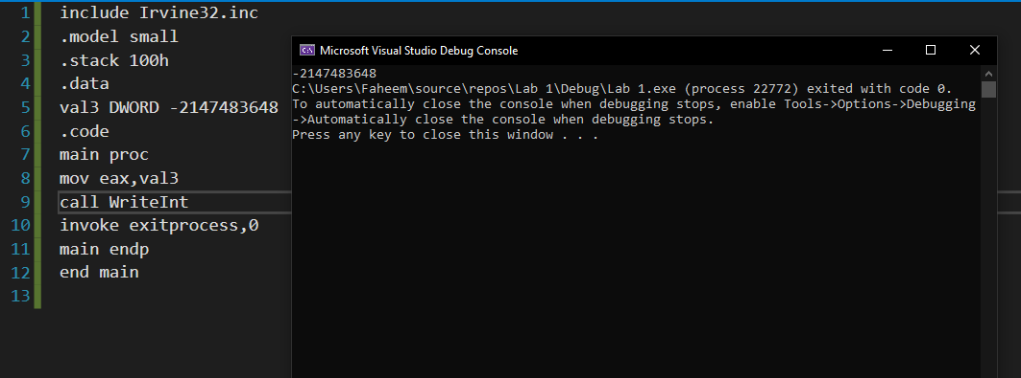

**Task # 3:** 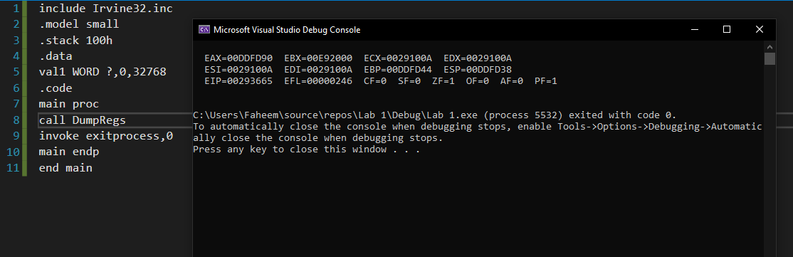

**Task # 4:** 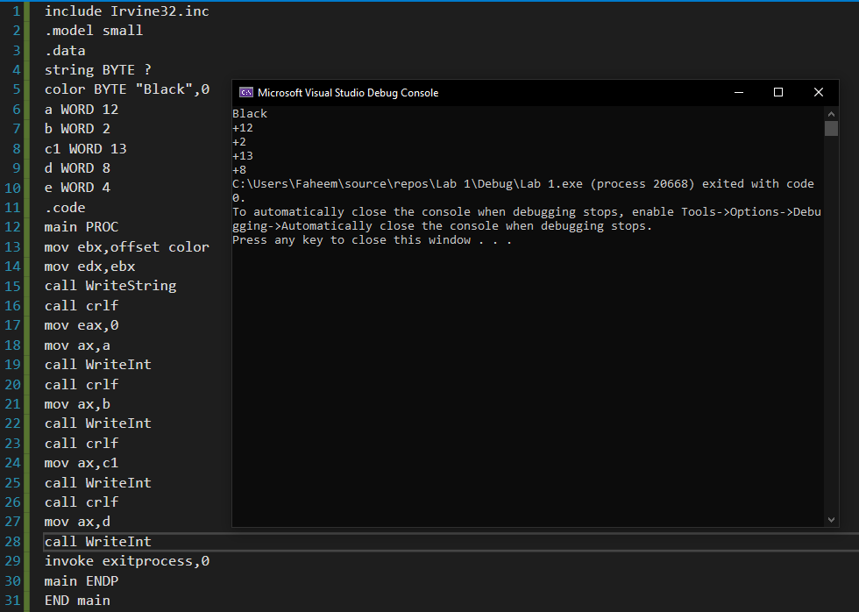

**Task # 5:**

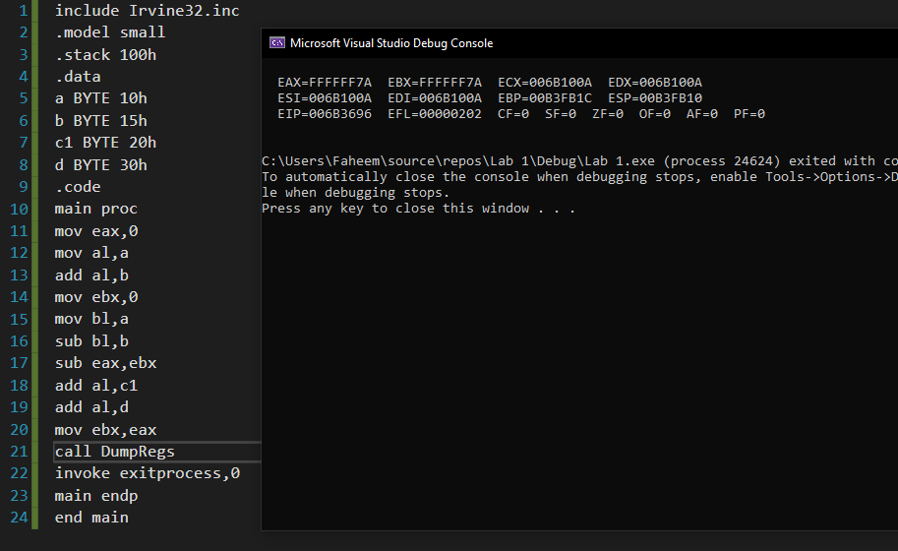

**Task # 6:** 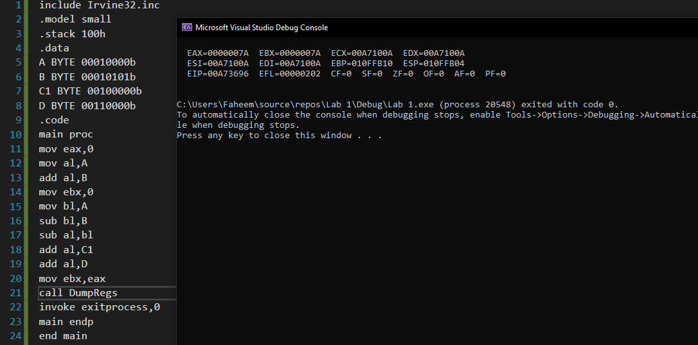

**Task # 7:**

